SQL Structured Query Language

Interview Question for SQL -https://www.youtube.com/playlist?list=PL6n9fhu94yhXcztdLO7i6mdyaegC8CJwR

Database

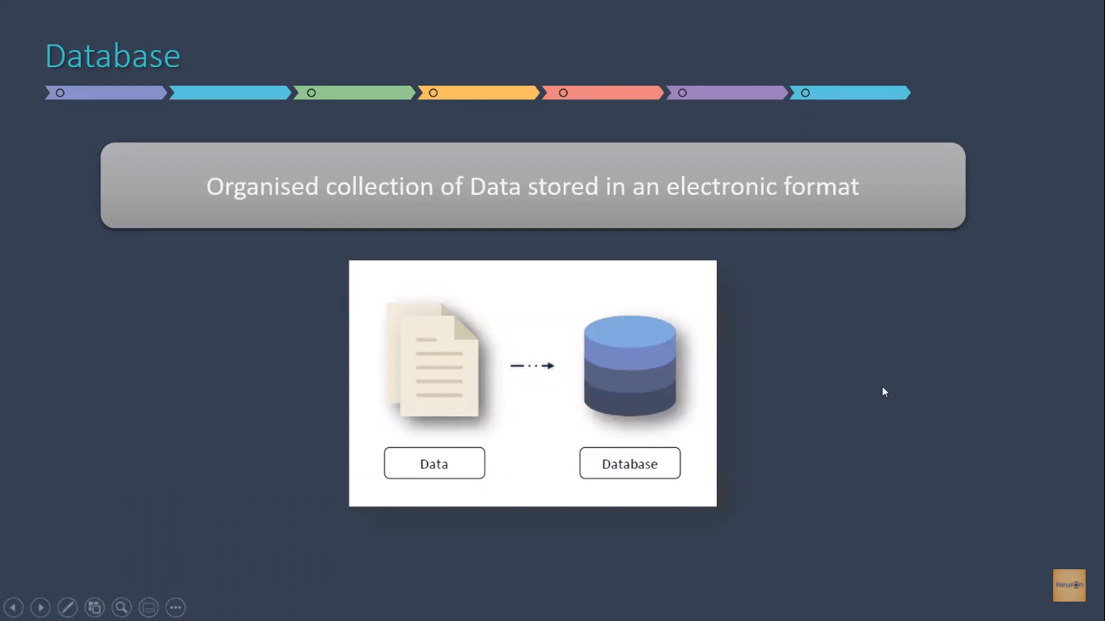

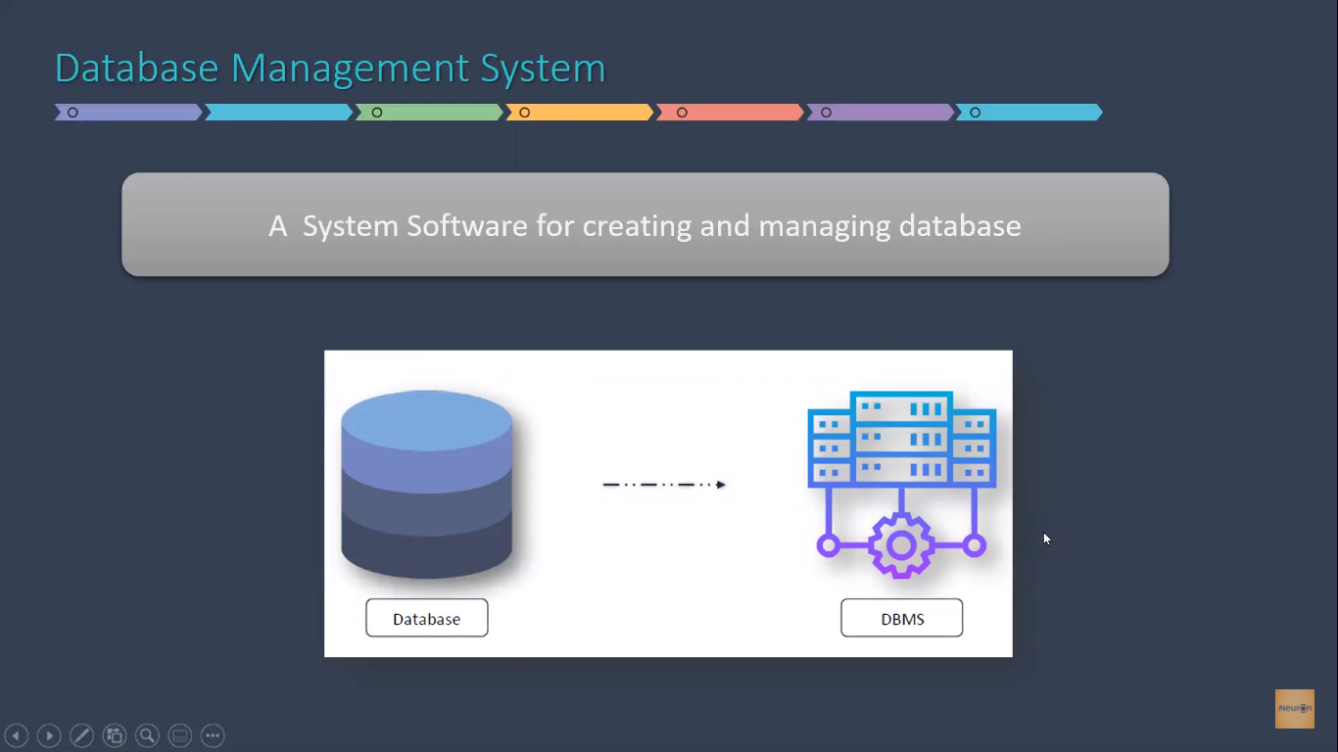

Database Architecture

File Sever and Client Server

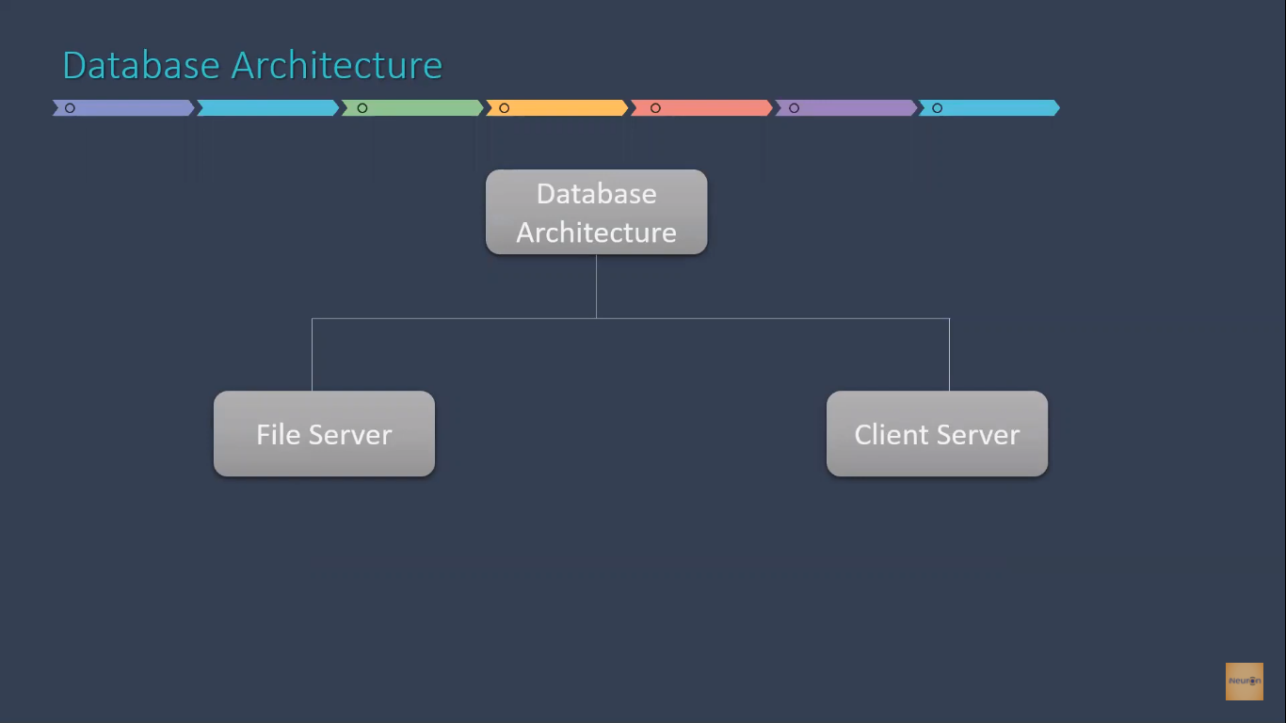

File Server

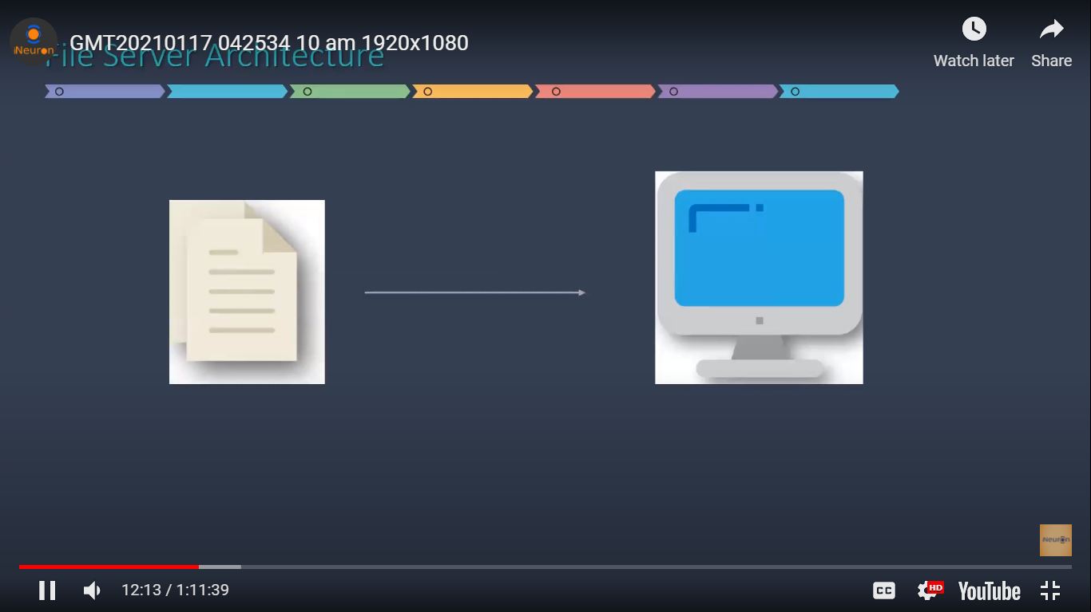

Client Server

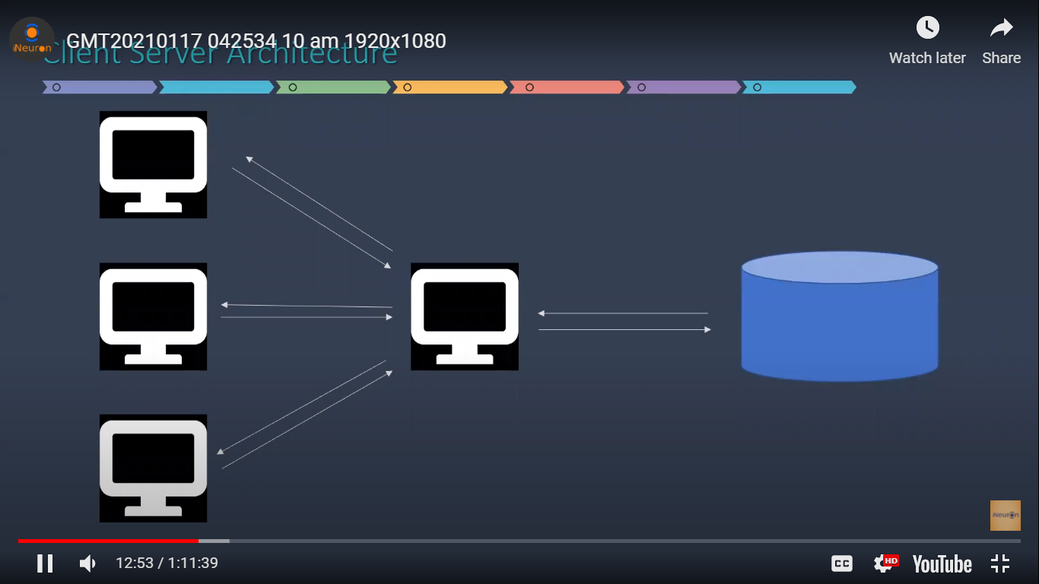

Installation Steps

Download the setup file [from](https://www.microsoft.com/en-in/sql-server/sql-server-downloads). Click on Developer Download Now.

Click on install.... Choose Custom Option…Install…. Click on Installation…Select New SQL Server standalone installation…. Specify free edition (Developer)…Next. Next…Select Database Engine Services…Next…Name your instance. Next. Next…Select Mixed Mode (SQL and authentication) Insert your SA (system admin) password, add current user…Next…..Click on Install.

Then install SQL server management tool (it is an interface through which we interact with SQL).

Click on download SSMS. Install..

Open SSMS and see that server type is Database Engine

Select your server name (instance name)

Authentication – select SQL server Authentication – Login sa – password you have set

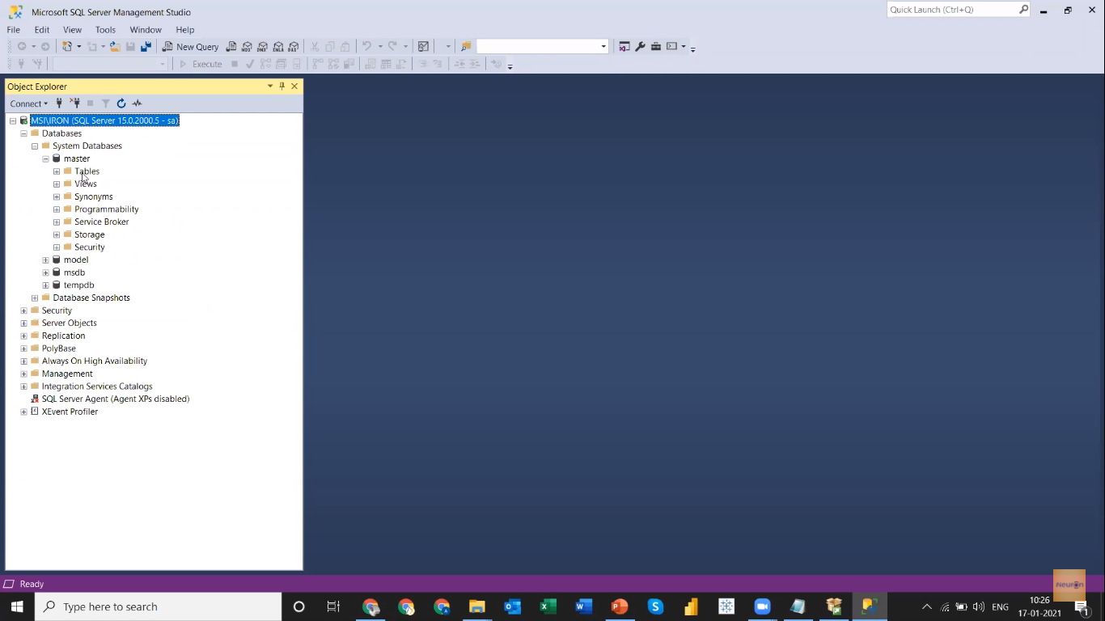

Tables

Databaserver

Serverrver

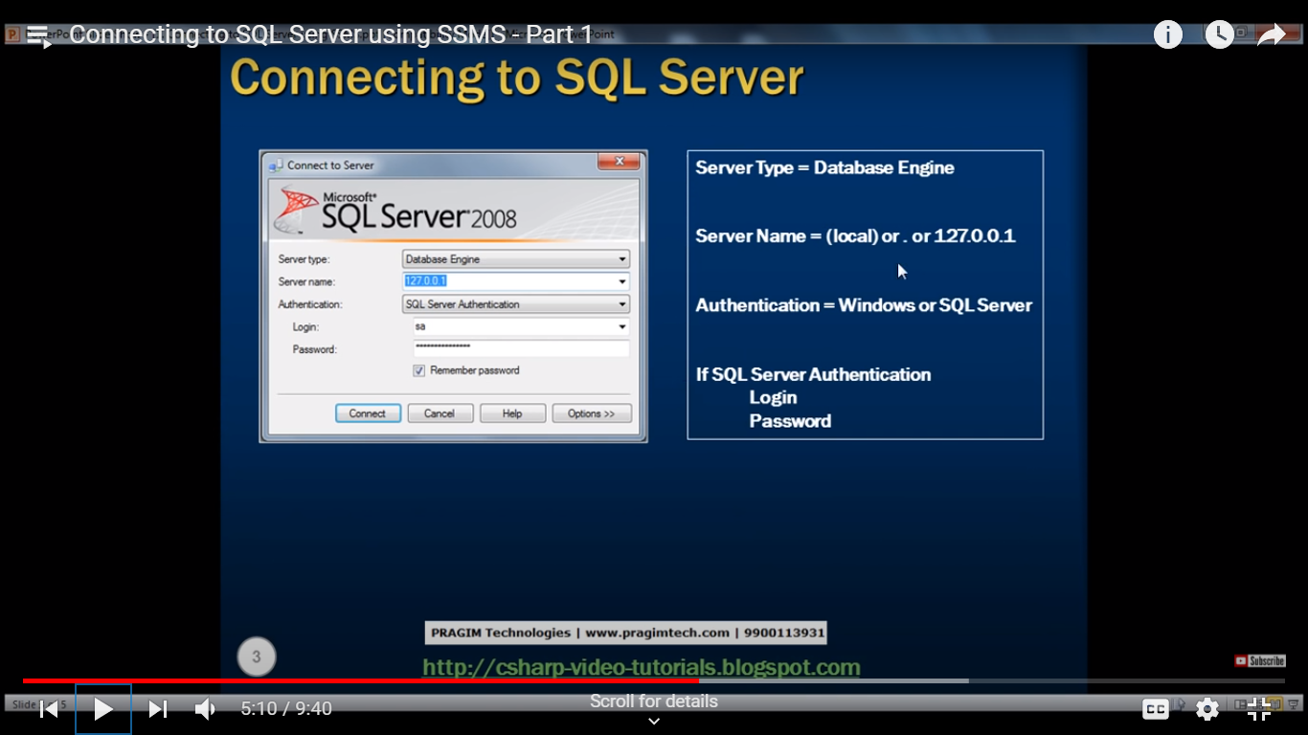

Restoring Database – Select Device- Add backup file under MySQL and search for your instance name. You need to that one by one it is not possible to do backup 3 files at one go

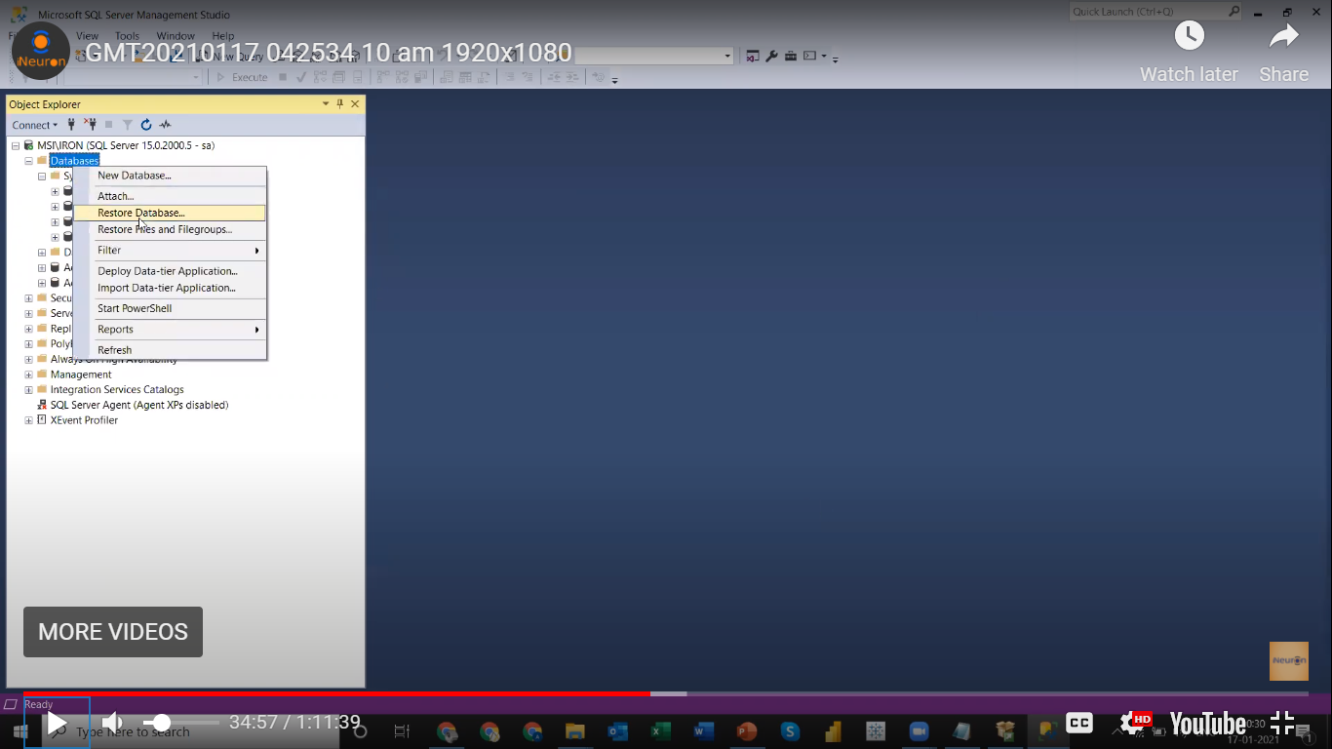

Record and Field

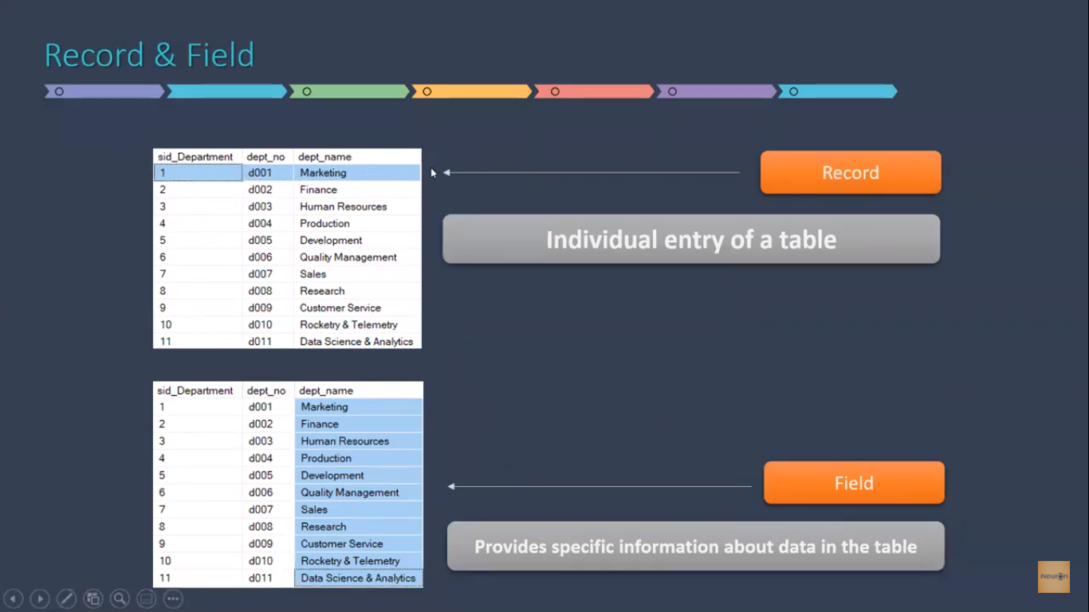

SQL Command Categories

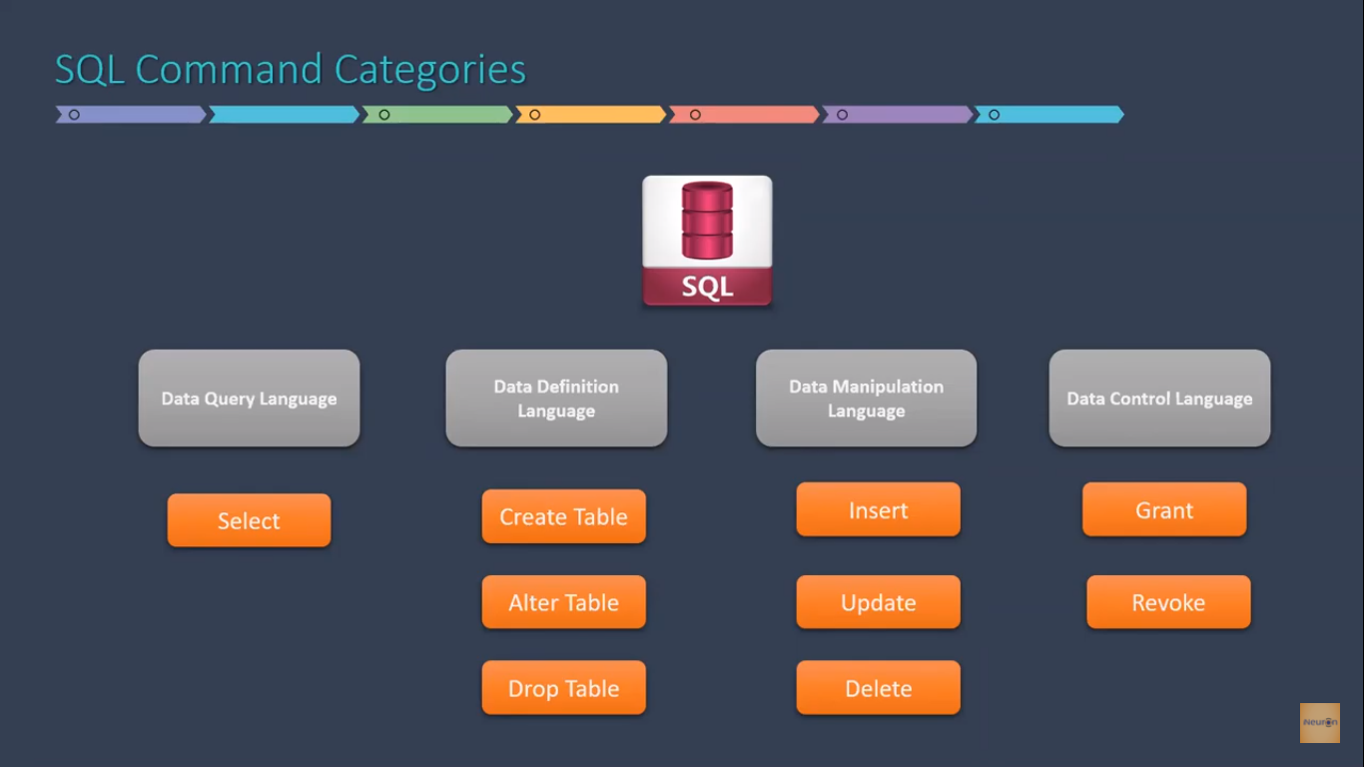

Numerical Data Type

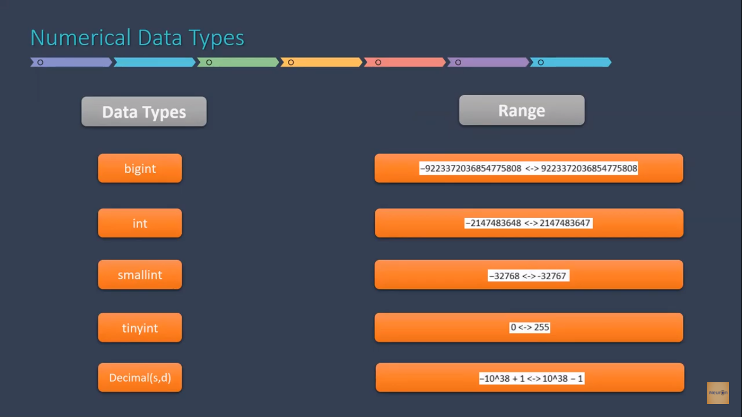

Character Data Types

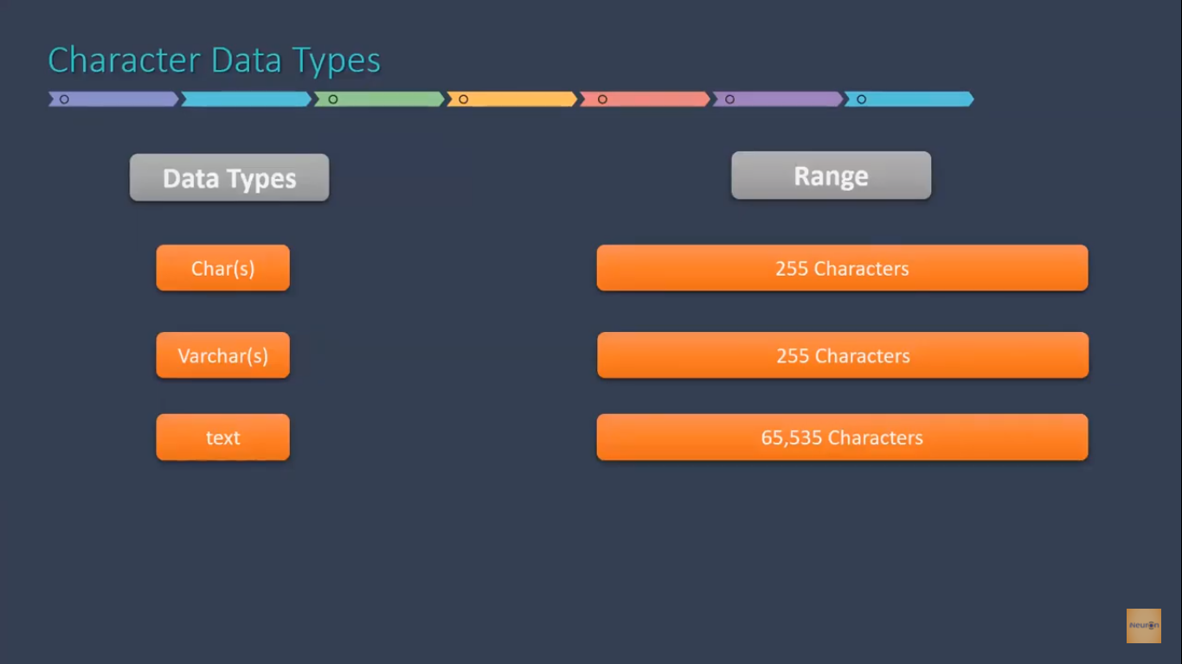

Date Time

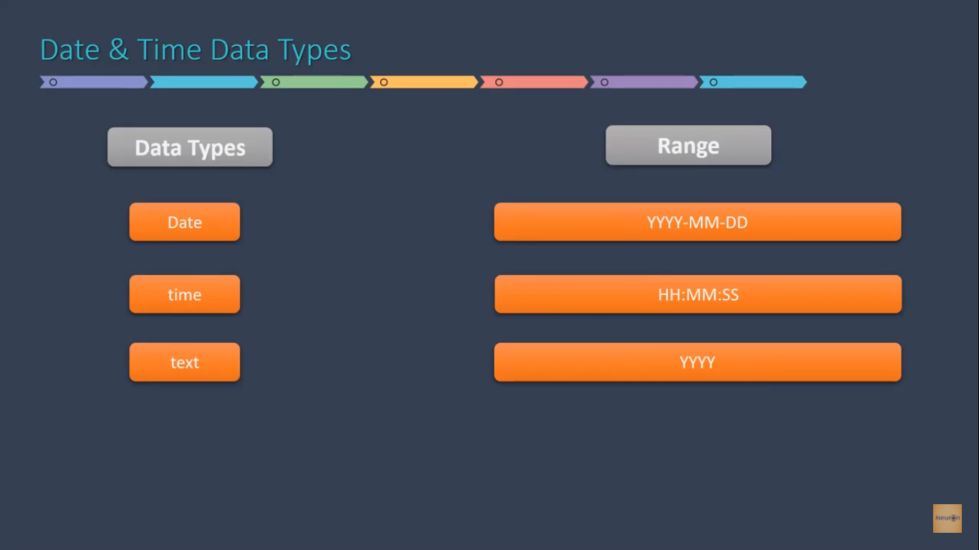

Constraint – These are the rules defined in the table

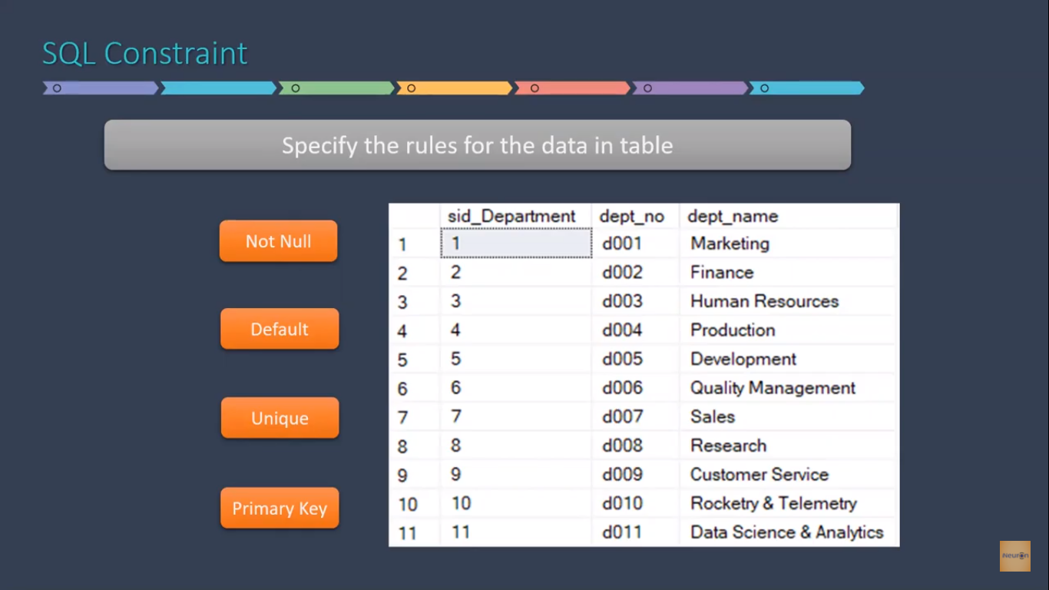

Relational Database

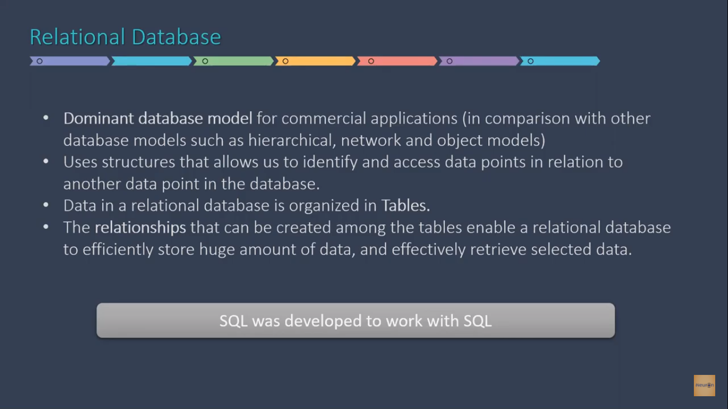

Design Process

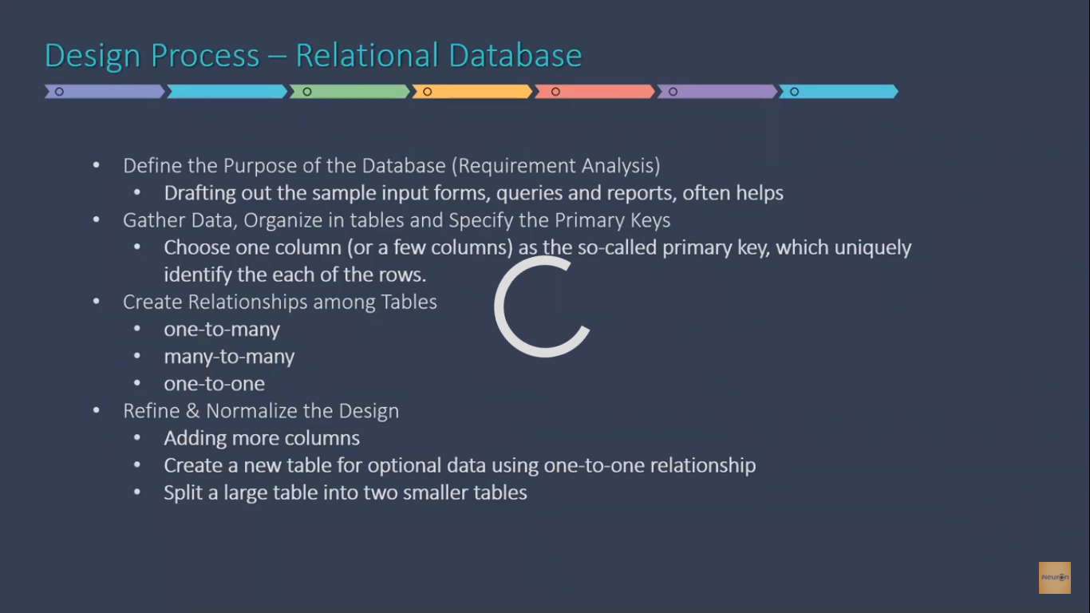

Primary and Foreign Key

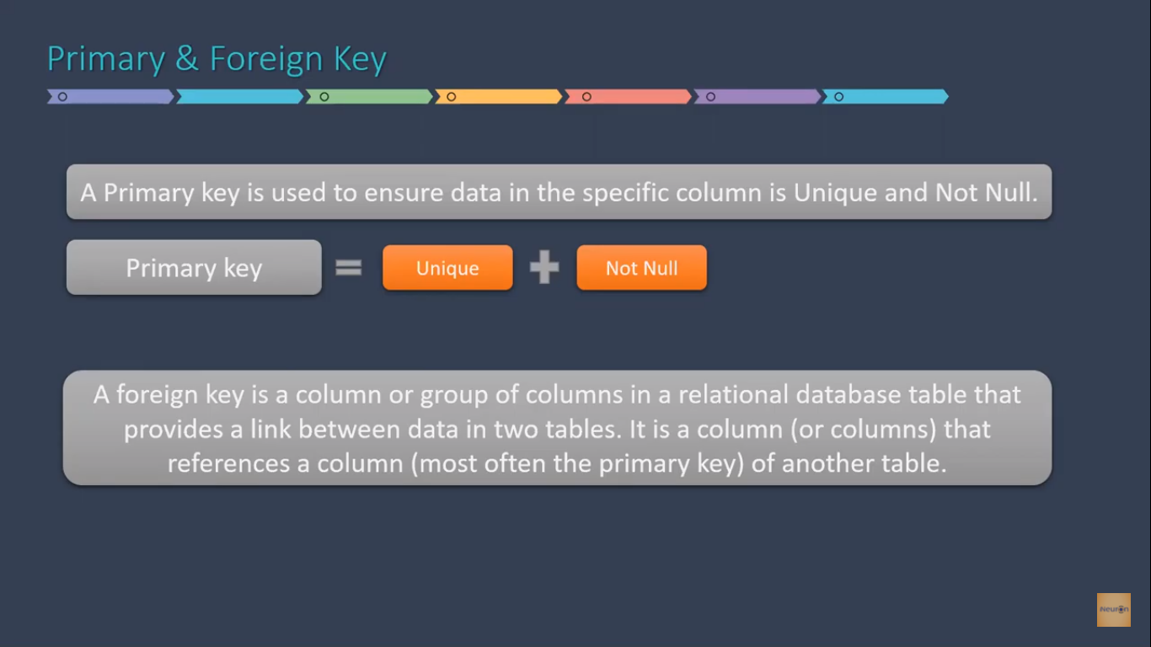

Alter Database

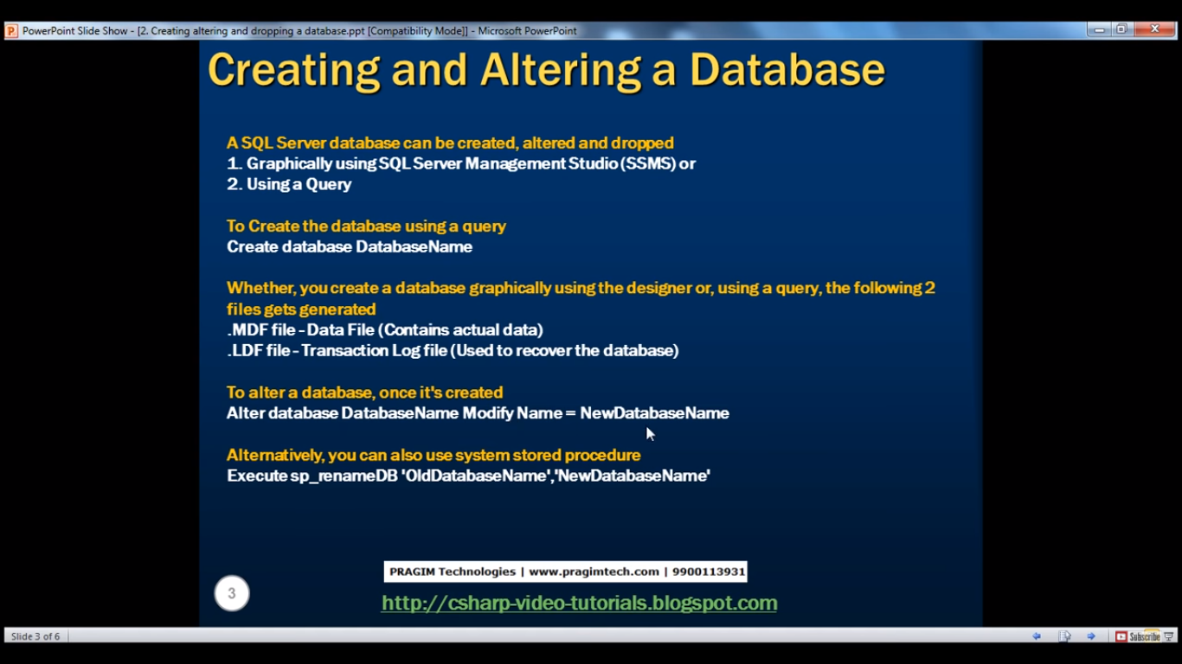

Delete Database

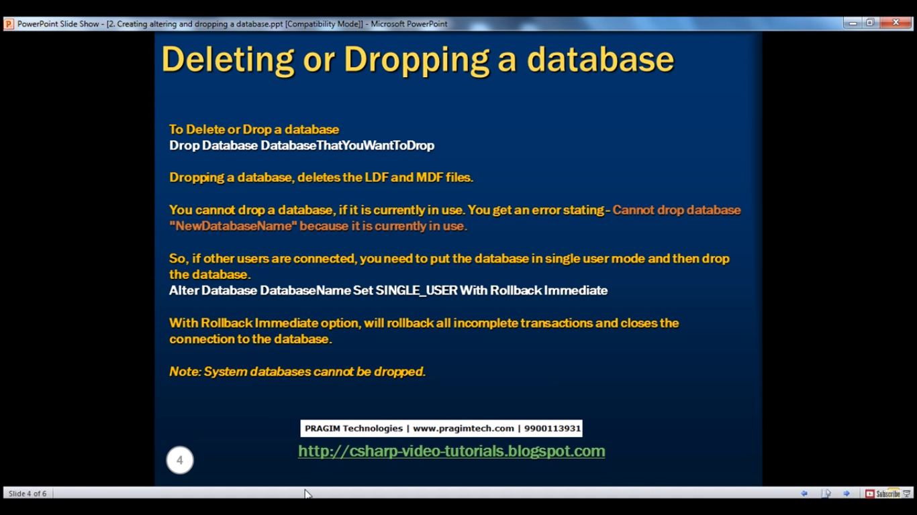

Creating Tables

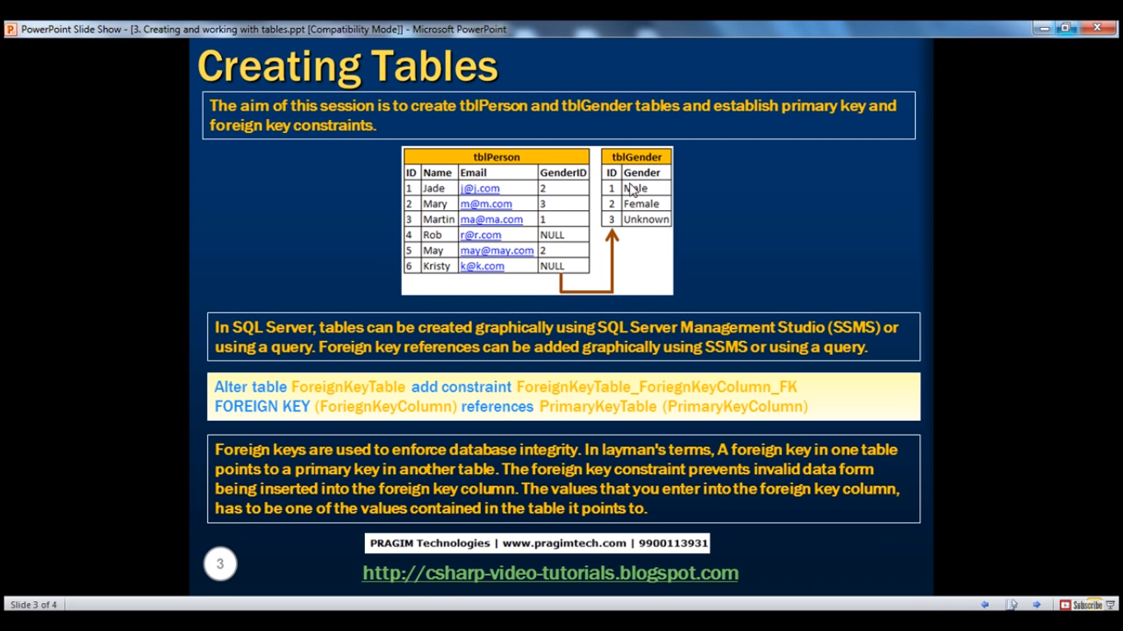

Default Constraint

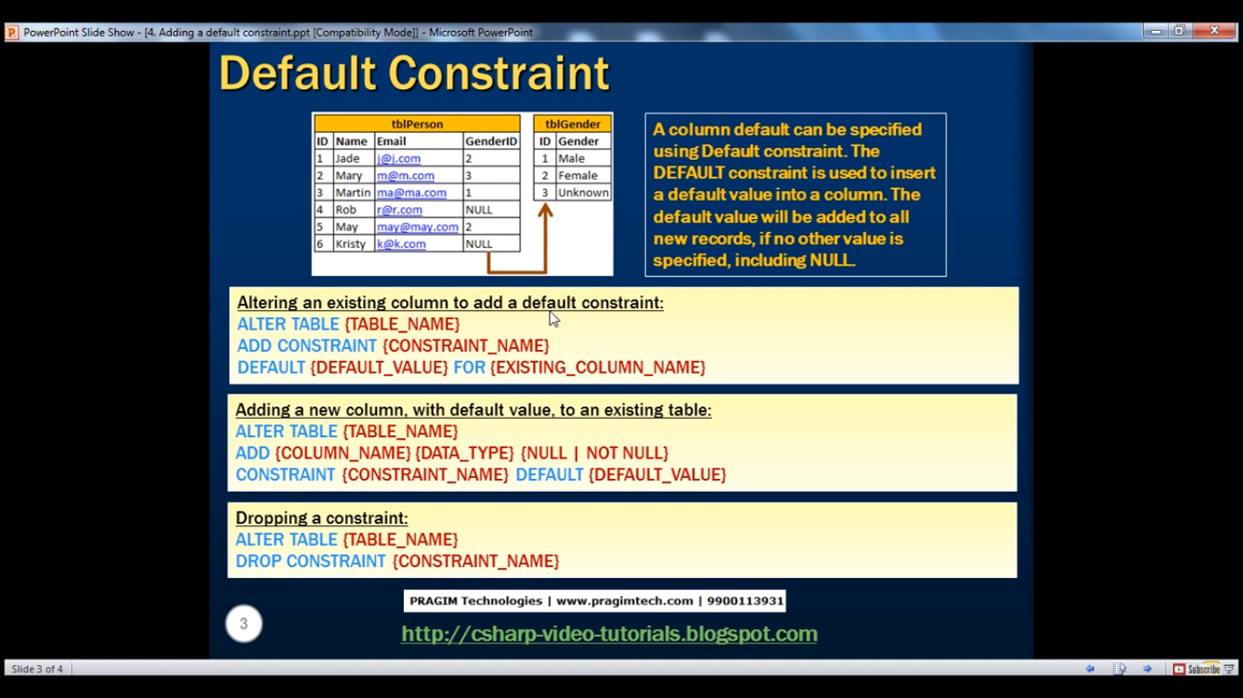

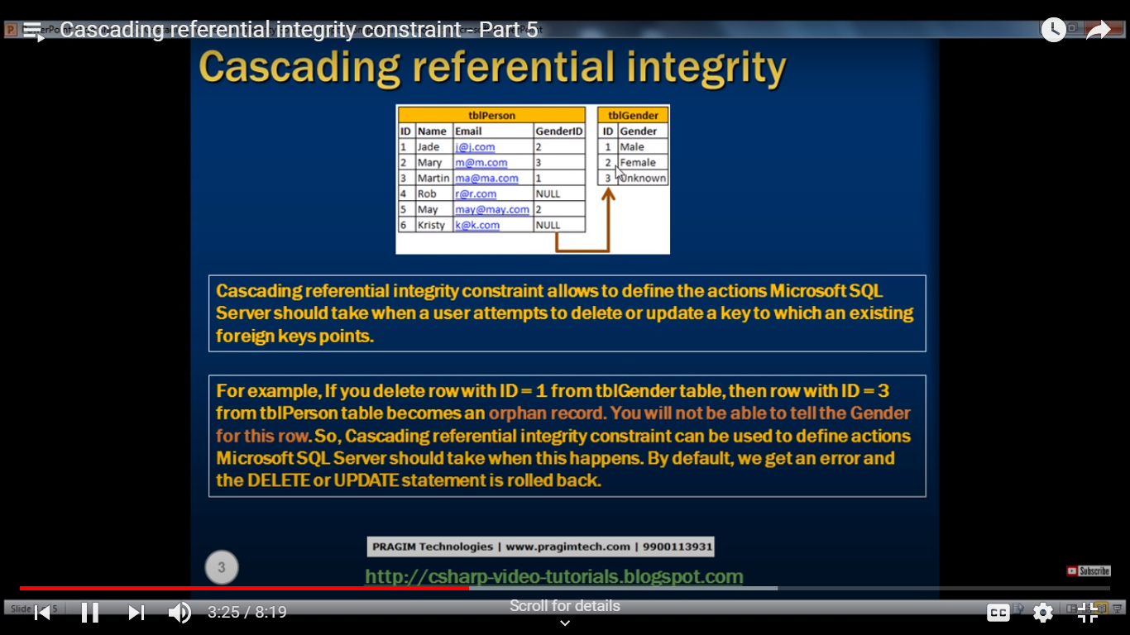

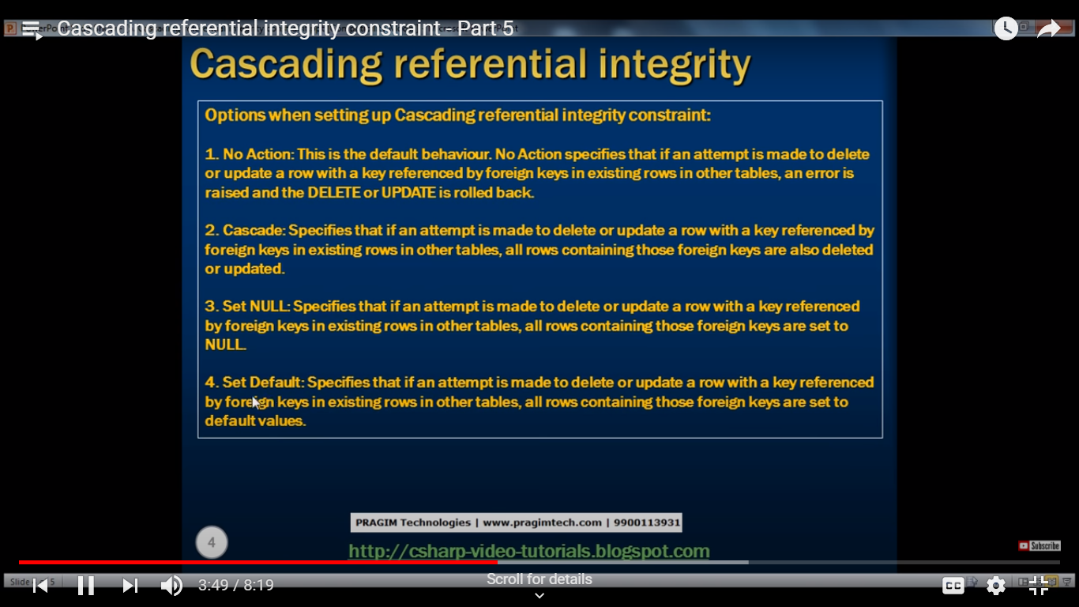

Cascade means it will delete the table. Set Default means if the Default Constraints is created it will add that value. Set Null- Insert Null Value. No Action – Give the error

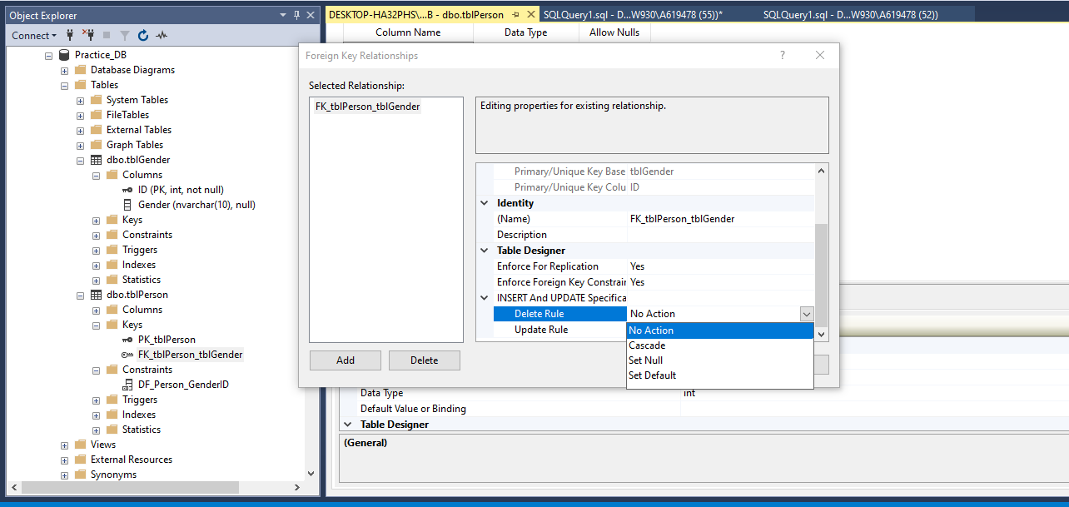

Select the table and press Alt + F1 for showing the data type of the column.

Check Constraints

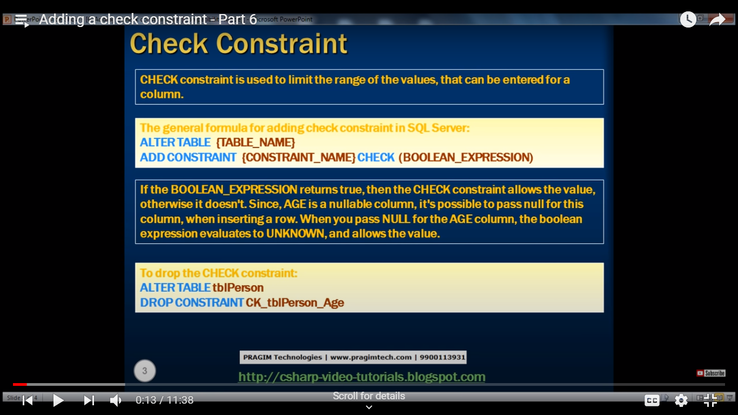

Identity Column

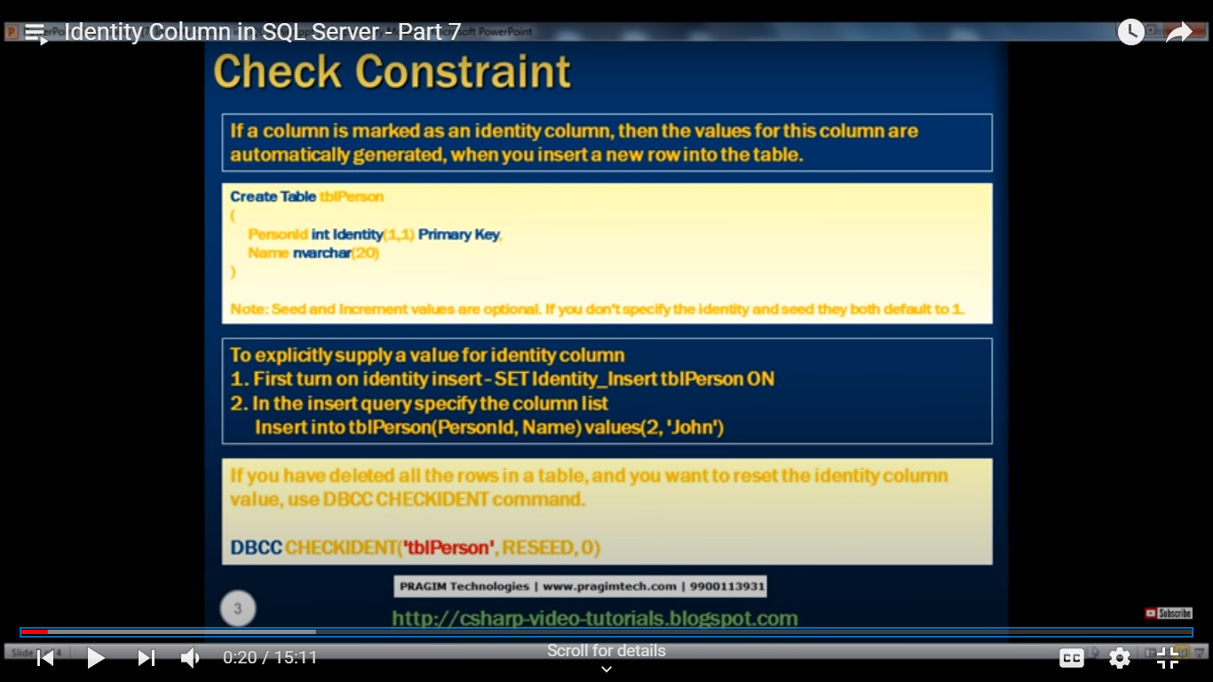

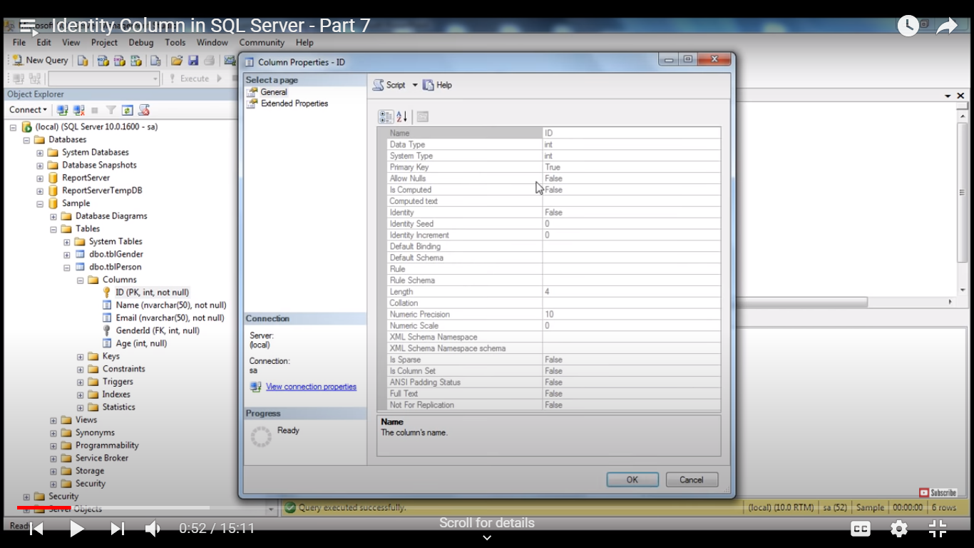

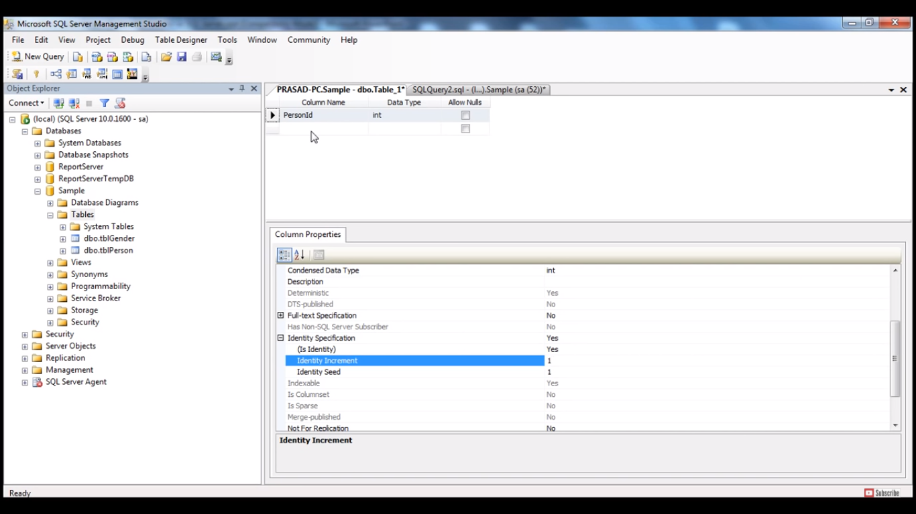

Identity Seed – Starting Value

Identity Increment – How much number you want to increment.

How to get the last generated identity column value in SQL Server - Part 8



Duplicate Database

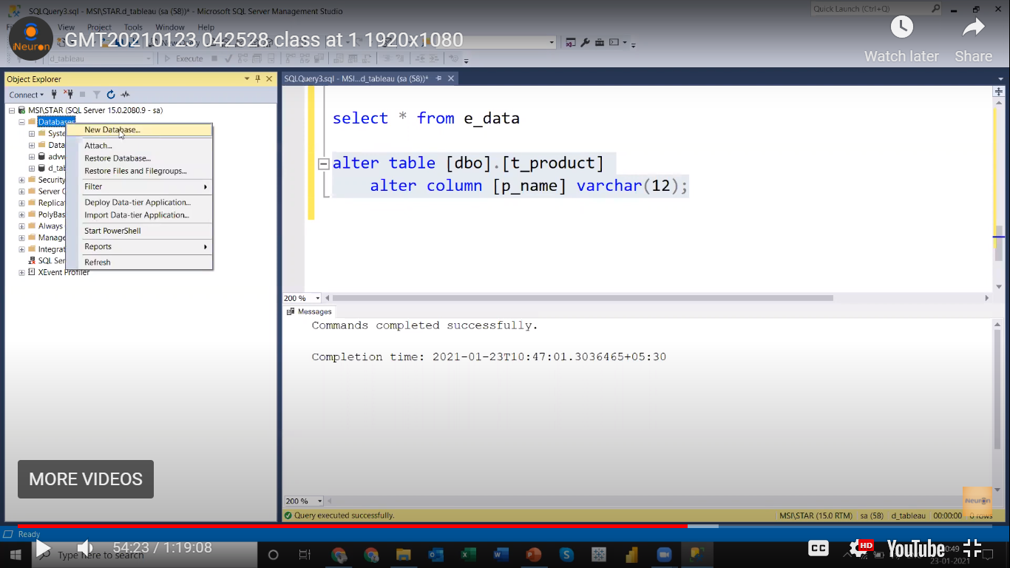

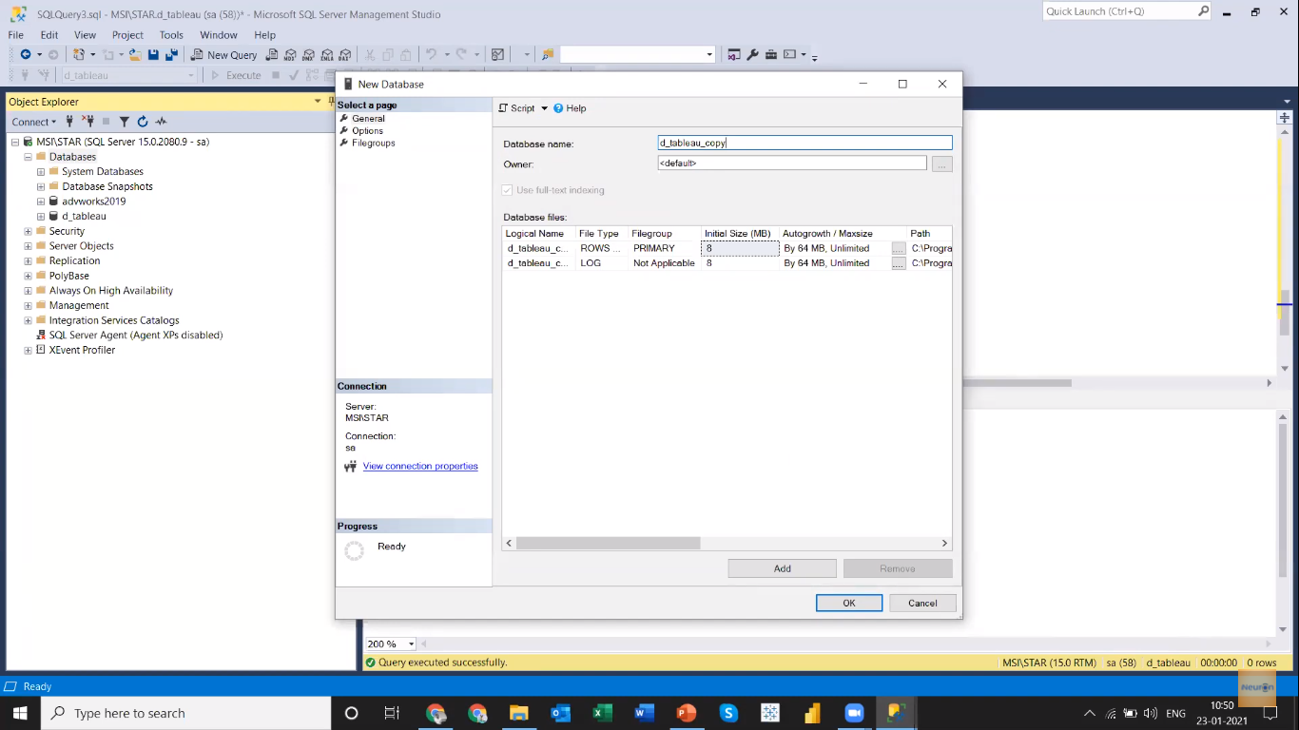

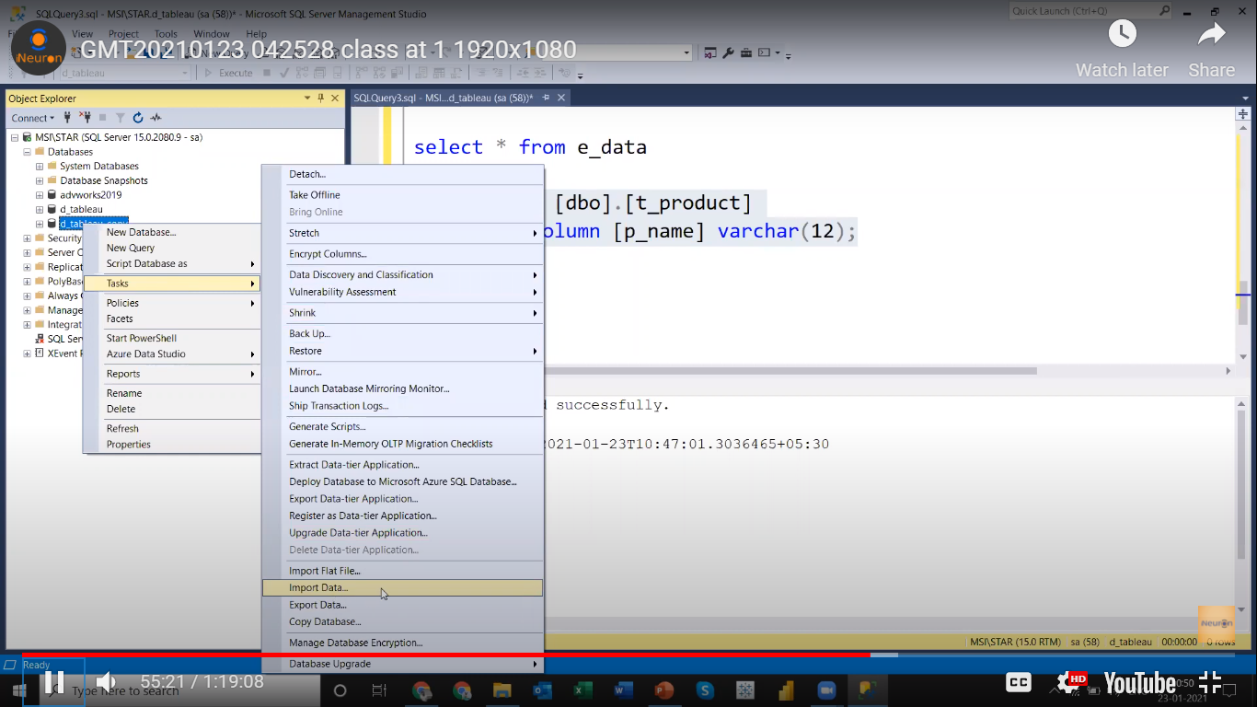

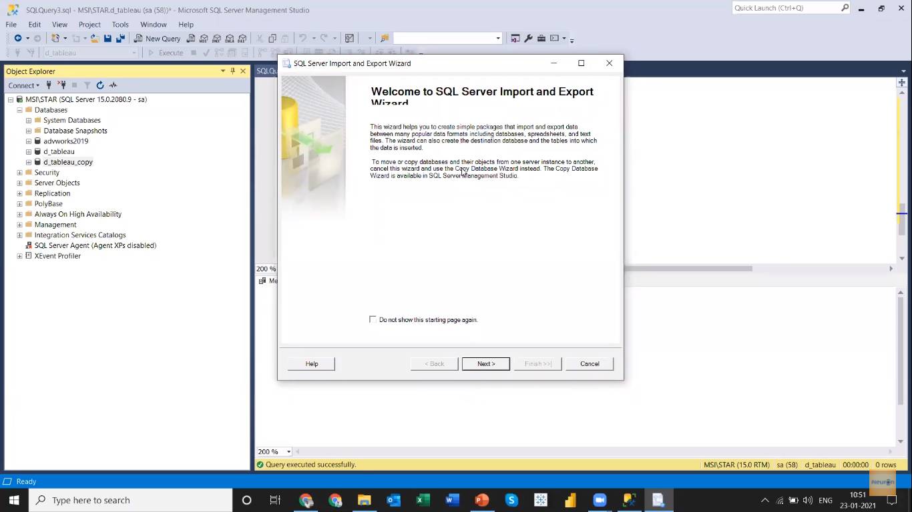

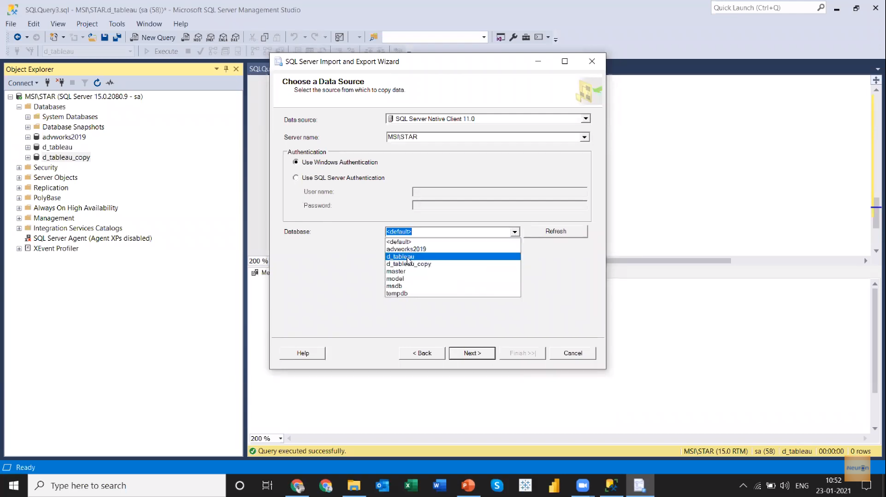

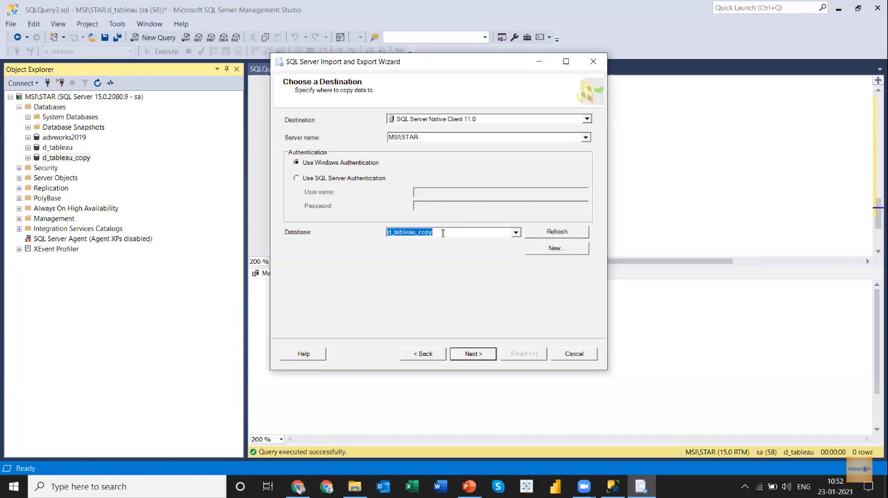

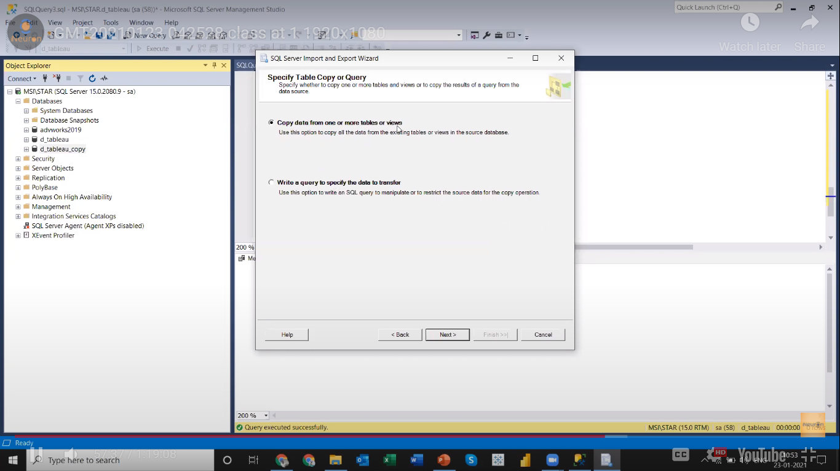

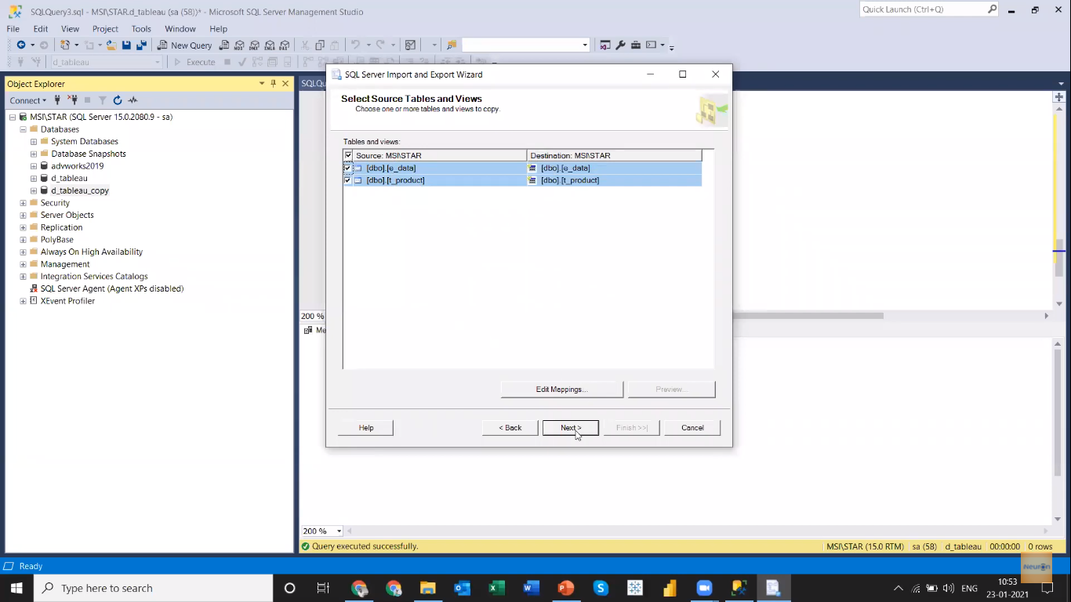

Next and Finish.

Backup Database

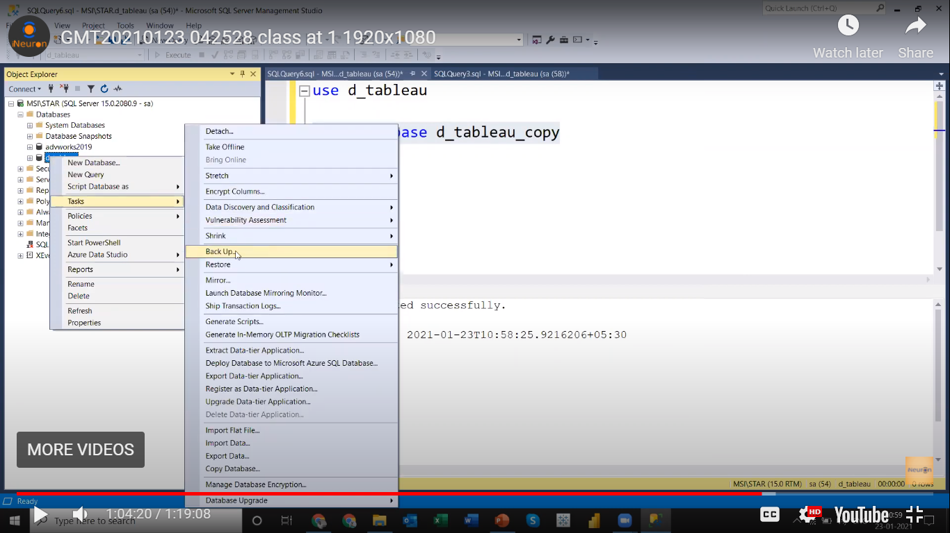

Interview Question

1. Finding nth Highest Salary

